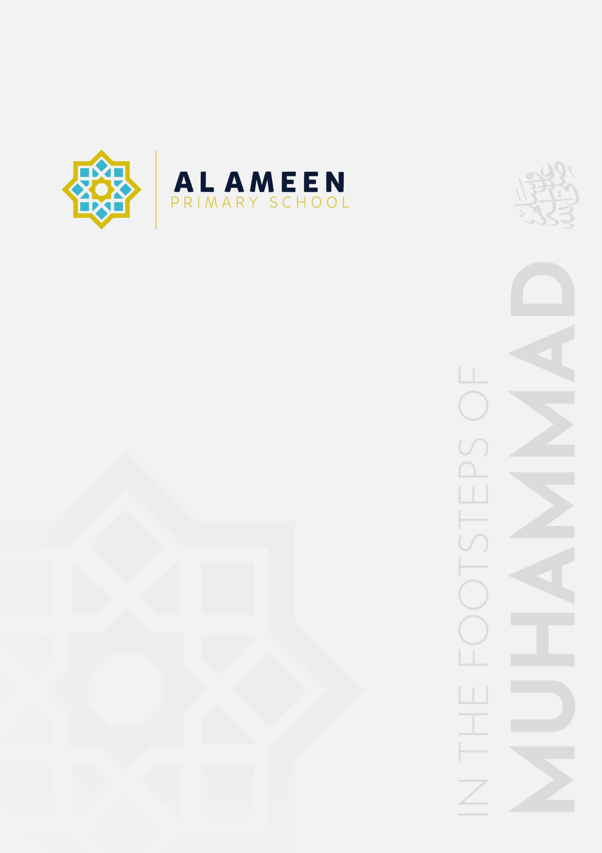

EARLY YEARS FOUNDATION STAGE
POLICY

Approved by: | Governing Board
Date effective from: | September 2026
Next review due by: | September 2027
Signed: | M M Uddin

In the name of Allah, The Beneficent, The Merciful
“My Lord, increase me in knowledge.” (Qur’an 20:114)
1. Aims
Al Ameen Primary School aims to provide a safe, nurturing and ambitious Early Years Foundation Stage (EYFS) in which every child is valued as a unique individual and is supported to develop spiritually, socially, emotionally, physically and academically. Our provision reflects our Islamic ethos while meeting the statutory requirements of the EYFS.
This policy aims to ensure that children learn and develop well and are kept healthy and safe; access a broad and balanced curriculum that provides a secure foundation for future learning; experience high-quality and consistent teaching; benefit from a close partnership between school and parents/carers; and are included and supported through equality of opportunity and anti-discriminatory practice.
Our practice is guided by the four overarching principles of the EYFS: the unique child; positive relationships; enabling environments with teaching and support from adults; and the importance of learning and development, recognising that children develop and learn at different rates.
2. Statutory framework and guidance
This policy is based on the Statutory Framework for the Early Years Foundation Stage for group and school-based providers, effective from 1 September 2026, and should be read alongside Keeping Children Safe in Education 2026 and the Independent School Standards. It also reflects the school’s safeguarding, SEND, equality, admissions, attendance, health and safety and other relevant policies.
2.1 Regulation and inspection
Al Ameen Primary School is inspected as a whole school by the Independent Schools Inspectorate (ISI), which reports on the school’s compliance with the Independent School Standards. Because the school also provides for children in the Early Years Foundation Stage, this provision is separately registered with, and regulated and inspected by, Ofsted, whose role in relation to the school is limited to early years registration and inspection. Ofsted may inspect the EYFS setting, and take regulatory action in respect of it, independently of and in addition to the ISI inspection cycle. Parents/carers may access the school’s most recent ISI report and the EYFS setting’s most recent Ofsted early years inspection outcome on request or via the relevant inspectorate’s published register.
3. Structure of the EYFS at Al Ameen
Al Ameen Primary School is an independent Islamic primary school. Our Early Years Foundation Stage comprises FS1 and FS2. FS1 provides for our younger early years children, while FS2 is our older early years group in the final stage of the EYFS before Year 1. Both groups follow the EYFS statutory framework and are planned as a coherent progression through the early years.
• FS1 – our younger early years group.
• FS2 – our older early years group, with increasing preparation for transition to Year 1.
4. Curriculum
Our early years provision follows the educational programmes in the EYFS framework. All seven areas of learning and development are important and interconnected. The three prime areas are Communication and Language; Physical Development; and Personal, Social and Emotional Development. The four specific areas are Literacy; Mathematics; Understanding the World; and Expressive Arts and Design.
Our curriculum is enriched by the school’s Islamic ethos. Children develop good character, manners, respect, gratitude and care for others through age-appropriate routines, stories, language, experiences and modelling. This enrichment is planned in a way that supports, rather than narrows, the breadth of the statutory EYFS educational programmes.
4.1 Planning
Staff are ambitious for all children. Planning takes account of children’s starting points, interests, prior learning, development and individual needs. Staff use their knowledge of children to provide a balance of purposeful play, adult-guided learning, direct teaching, exploration, talk, stories, practical experiences and opportunities to revisit and apply learning.
Where staff identify that a child may need additional support, this is discussed promptly with parents/carers and, where appropriate, the SENDCo. Staff make reasonable adjustments, adapt provision and seek specialist advice or support from external agencies when required.
4.2 Teaching and characteristics of effective learning
Staff recognise that play is essential to children’s development and that high-quality adult interaction can extend vocabulary, thinking, independence and understanding. Children are supported to experience the characteristics of effective teaching and learning: playing and exploring; active learning; and creating and thinking critically.
As children grow older and their development allows, the balance gradually shifts towards more focused teaching of essential knowledge and skills in the specific areas of learning, while retaining purposeful play and developmentally appropriate practice. In FS2, particular attention is given to language, early reading, writing and mathematics, alongside the full breadth of the EYFS curriculum, so that children are well prepared for Year 1.
4.3 Early reading and phonics
The school uses Read Write Inc. as its systematic approach to phonics. In the EYFS, staff build strong foundations in speaking, listening, vocabulary, phonological awareness and a love of books, before and alongside the systematic teaching of phonics at an appropriate stage. Children are given frequent opportunities to hear high-quality stories, rhymes and poems and to develop comprehension through discussion and retelling.
5. Assessment
Ongoing assessment is an integral part of learning and development. Practitioners observe and interact with children to understand their progress, attainment, interests and needs, and use this knowledge to shape teaching and provision. Assessment is proportionate and is based primarily on staff knowledge and professional judgement; staff are not required to create unnecessary physical evidence.
Parents/carers are kept informed about their child’s progress and are encouraged to share information about learning, development and significant experiences at home. Where learning or development needs are identified, the school works in partnership with parents/carers and relevant professionals.
5.1 Progress check at age 2
Where the school provides for a child between the ages of 2 and 3 and is responsible for the statutory progress check, parents/carers will receive a written summary of the child’s development in the three prime areas. The check will identify strengths, areas where additional support may be needed and any concerns about possible developmental delay, disability or special educational need, together with agreed strategies and actions.
5.2 EYFS Profile
In the final term of the academic year in which a child reaches age 5, and no later than 30 June in that term, the school will complete the EYFS Profile where required by the statutory framework. Each child is assessed against the 17 Early Learning Goals as either meeting the expected level of development or not yet reaching the expected level (“emerging”). The profile is based on practitioners’ knowledge and professional judgement and is shared with parents/carers and the child’s Year 1 teacher.
The EYFS Profile will be completed for children with SEND, with appropriate reasonable adjustments to the assessment process. The school will submit EYFS Profile data to the local authority when required.
6. Working with parents and carers
We recognise that children learn and develop best when there is a strong partnership between school and home. Parents/carers receive information about their child’s learning, development and wellbeing through regular communication, including ClassDojo, informal discussion, planned parent meetings and reports or statutory assessments as appropriate.
Each child is assigned a key person. The key person helps ensure that learning and care are tailored to the child’s needs, supports parents/carers in guiding development at home and helps families access specialist support where appropriate. We ask parents/carers to provide more than two emergency contact numbers where possible and to keep contact, medical and collection information up to date.
7. Staffing
The EYFS is led and managed by appropriately experienced staff. Staff deployment is organised to meet children’s needs, maintain effective supervision and comply with the statutory qualification and ratio requirements that apply to the provision. Staff receive induction, supervision, safeguarding updates and relevant professional development.
7.1 Staffing ratios
The school ensures that appropriate statutory staff-to-child ratios are maintained in accordance with the current EYFS framework. Staff are deployed effectively to meet children’s needs, ensure their safety and provide appropriate supervision throughout the day, including during breaks, meals and outings.
7.2 Safer recruitment, training and whistleblowing
Recruitment and suitability checks are carried out in accordance with the EYFS framework, Keeping Children Safe in Education and the school’s Safer Recruitment and Safeguarding policies. Required identity, qualification, reference, DBS and other vetting information is recorded on the Single Central Record and/or relevant personnel records.
All EYFS staff receive safeguarding training at induction and regular updates thereafter. Staff know how to raise concerns about poor or unsafe practice through the school’s whistleblowing procedures. Concerns about the Headteacher are reported to the Chair of Governors; other allegations and low-level concerns are managed in accordance with the Safeguarding Policy and KCSIE.
7.3 Disqualification, including disqualification by association
In accordance with the statutory guidance Disqualification under the Childcare Act 2006, no one who is disqualified from working in early years provision may work, or be present unsupervised, in the school’s EYFS setting. Disqualification can arise not only from a person’s own conduct, conviction, caution or order, but also “by association” — for example because of the conduct, conviction, caution or order of another person living or working in the same household. All staff working in the EYFS setting must declare, without delay, any change in their own circumstances or in the circumstances of someone in their household that may affect their suitability, including under the disqualification-by-association provisions. Any such disclosure is managed in accordance with the school’s Safeguarding and Safer Recruitment policies, and, where relevant, a waiver is sought from Ofsted before a disqualified person may continue to work or be present in the setting.
7.4 Allegations against staff in early years settings
The school follows Keeping Children Safe in Education and its Allegations Against Staff Policy when responding to an allegation or concern about a member of staff, volunteer or visitor working with EYFS children. For early years provision, the threshold for referral to the Local Authority Designated Officer (LADO) is lower than the general KCSIE threshold: a referral is made wherever a person who works with children in the EYFS may have behaved in a way that indicates they may not be suitable to work with children, including where they may have caused harm to a child, rather than only where “serious harm” may have been caused. Any such concern is reported to the DSL or, where the concern involves the DSL, to the Headteacher or Chair of Governors, and is acted on promptly rather than investigated informally or delayed pending further evidence.
8. Safeguarding and welfare
Children learn best when they are healthy, safe and secure, when their individual needs are met and when they have positive relationships with the adults caring for them. All practitioners remain alert to safeguarding concerns in children’s lives at home, in school or elsewhere and follow the school’s Child Protection and Safeguarding Policy.
8.1 Designated safeguarding lead
The school has a Designated Safeguarding Lead (DSL) and trained deputies. The DSL has lead responsibility for safeguarding and child protection, provides ongoing advice and support to staff, liaises with statutory services and safeguarding partners, and undertakes training that meets current statutory requirements.
8.2 Paediatric first aid
At least one person with a current full paediatric first aid (PFA) certificate, meeting the criteria in the EYFS framework, will be on the premises and available at all times when EYFS children are present and will accompany EYFS children on outings. PFA certificates are renewed within the required period. Staff deployment and rotas are planned so that this requirement is maintained throughout the day, including breaks, transitions and outdoor provision.
8.3 Attendance and absence
The school follows up unexplained or concerning absence promptly. Where a child is absent and the reason is not known, staff will contact parents/carers and, where necessary, alternative emergency contacts. Patterns, trends and the child’s circumstances are considered, and safeguarding referrals or welfare checks are made where appropriate. Further detail is set out in the Attendance Policy.
8.4 Health, oral health and safer eating
Children are supported to understand healthy choices, including healthy food, physical activity and the importance of brushing teeth. Meals, snacks and drinks provided by the school are planned with regard to the EYFS nutrition guidance, dietary needs, allergies and intolerances. Fresh drinking water is available.
Before admission, the school obtains relevant information about dietary requirements, allergies, intolerances and health needs. Allergy information and action plans are shared appropriately with staff. While children are eating, they are supervised within sight and hearing and the school ensures the required PFA-trained member of staff is present. Food is prepared and served in a way that reduces choking risk and is appropriate to children’s developmental needs.
8.5 Accidents, injuries and medicines
Appropriate first-aid equipment is accessible. Accidents, injuries and first-aid treatment are recorded and parents/carers are informed on the same day or as soon as reasonably practicable. Serious incidents are reported to the relevant authority within statutory timescales. Medicines are administered only in accordance with the school’s Supporting Pupils with Medical Conditions/Medicines procedures and with appropriate parental consent and records.
8.6 Premises, fire safety and security
EYFS premises and outdoor areas are suitable for the age and needs of children and comply with applicable health, safety, fire and hygiene requirements. The school maintains emergency evacuation procedures, suitable fire detection and control equipment, clear exits and procedures for checking visitors and preventing unauthorised access. Children are not permitted to leave the premises unsupervised and are released only to persons authorised by parents/carers.
8.7 Toileting, intimate care and privacy
The school provides suitable toilets and handwashing facilities and, where required, hygienic changing facilities. Staff balance children’s dignity and privacy with safeguarding and supervision needs. Intimate care is provided sensitively in accordance with the school’s procedures, with appropriate records and communication with parents/carers.
8.8 Screen use
The school has regard to current Department for Education guidance on screen use in early years. Digital technology is used purposefully and in moderation, with priority given to talk, movement, play, practical exploration, books, creativity and interaction with adults and other children.
8.9 Safer sleep practice
Where EYFS children sleep or rest at school, staff follow current safer sleep guidance, including that published by The Lullaby Trust, to minimise the risk of sudden infant death and to keep children safe while sleeping. Children are placed on their backs to sleep unless a documented individual care plan, agreed with parents/carers and, where relevant, health professionals, states otherwise. Sleeping children are checked regularly and systematically, checks are recorded, and staff remain within sight and/or hearing of sleeping children at all times. Cots, mats and other sleep equipment are age-appropriate and safe, and are kept free of loose bedding, pillows, cot bumpers and other hazards. Parents/carers are consulted about their child’s sleep needs and preferences, and individual arrangements are recorded and reviewed.
9. SEND, inclusion and equality
The school identifies and responds to emerging needs at the earliest opportunity. EYFS staff work closely with the school SENDCo, parents/carers and external professionals. Support is graduated, child-centred and reviewed regularly. Reasonable adjustments are made so that children with disabilities and SEND can participate as fully as possible in the curriculum and wider life of the school.
Our EYFS promotes respect for others and equality of opportunity in line with the school’s Equality Policy. Resources, stories, experiences and adult interactions are chosen and used thoughtfully so that children learn to value themselves, their families and the wider community while developing respect for people from different backgrounds.
10. Transition
Transitions into FS1, between FS1 and FS2, and from FS2 into Year 1 are planned carefully. Staff share relevant information about each child’s learning, development, wellbeing, SEND, medical needs and safeguarding considerations. Transition activities are adapted where children require additional preparation or support.
11. Monitoring and review
The Headteacher and EYFS lead monitor implementation of this policy through observation of practice, safeguarding and welfare checks, assessment information, staff supervision, parent feedback and review of statutory compliance. The policy will be reviewed annually, or sooner if statutory requirements or the organisation of the provision changes, and will be approved by the Governing Board.
12. Links with other school policies
This policy should be read alongside the Child Protection and Safeguarding Policy; Attendance Policy; Admissions Policy; SEND Policy and SEND Information Report; Equality Policy; Behaviour and Anti-Bullying Policy; Health and Safety Policy; Fire and Emergency Evacuation procedures; Supporting Pupils with Medical Conditions/Medicines Policy; Intimate Care procedures; Safer Recruitment Policy; Whistleblowing Policy; Complaints Policy; and relevant curriculum policies.
Appendix 1. Key EYFS statutory procedures and where they are addressed
Requirement / procedure | School document / arrangement
Safeguarding and child protection | Child Protection and Safeguarding Policy
Illness, accidents and first aid | Health and Safety Policy and first-aid procedures
Administering medicines | Supporting Pupils with Medical Conditions / medicines procedures
Emergency evacuation | Fire and Emergency Evacuation procedures
Visitor identity and site security | Safeguarding Policy and visitor procedures
Failure to collect / missing child | Safeguarding procedures
Concerns and complaints | Complaints Policy
SEND and reasonable adjustments | SEND Policy / SEND Information Report / Equality Policy
Attendance and unexplained absence | Attendance Policy
Regulation and inspection (Ofsted early years registration) | Section 2.1 of this policy; Safeguarding Policy
Disqualification, including disqualification by association | Section 7.3 of this policy; Safeguarding and Safer Recruitment Policies
Allegations against EYFS staff (lowered referral threshold) | Section 7.4 of this policy; Safeguarding Policy; Allegations Against Staff Policy
Safer sleep practice | Section 8.9 of this policy; Health and Safety Policy

