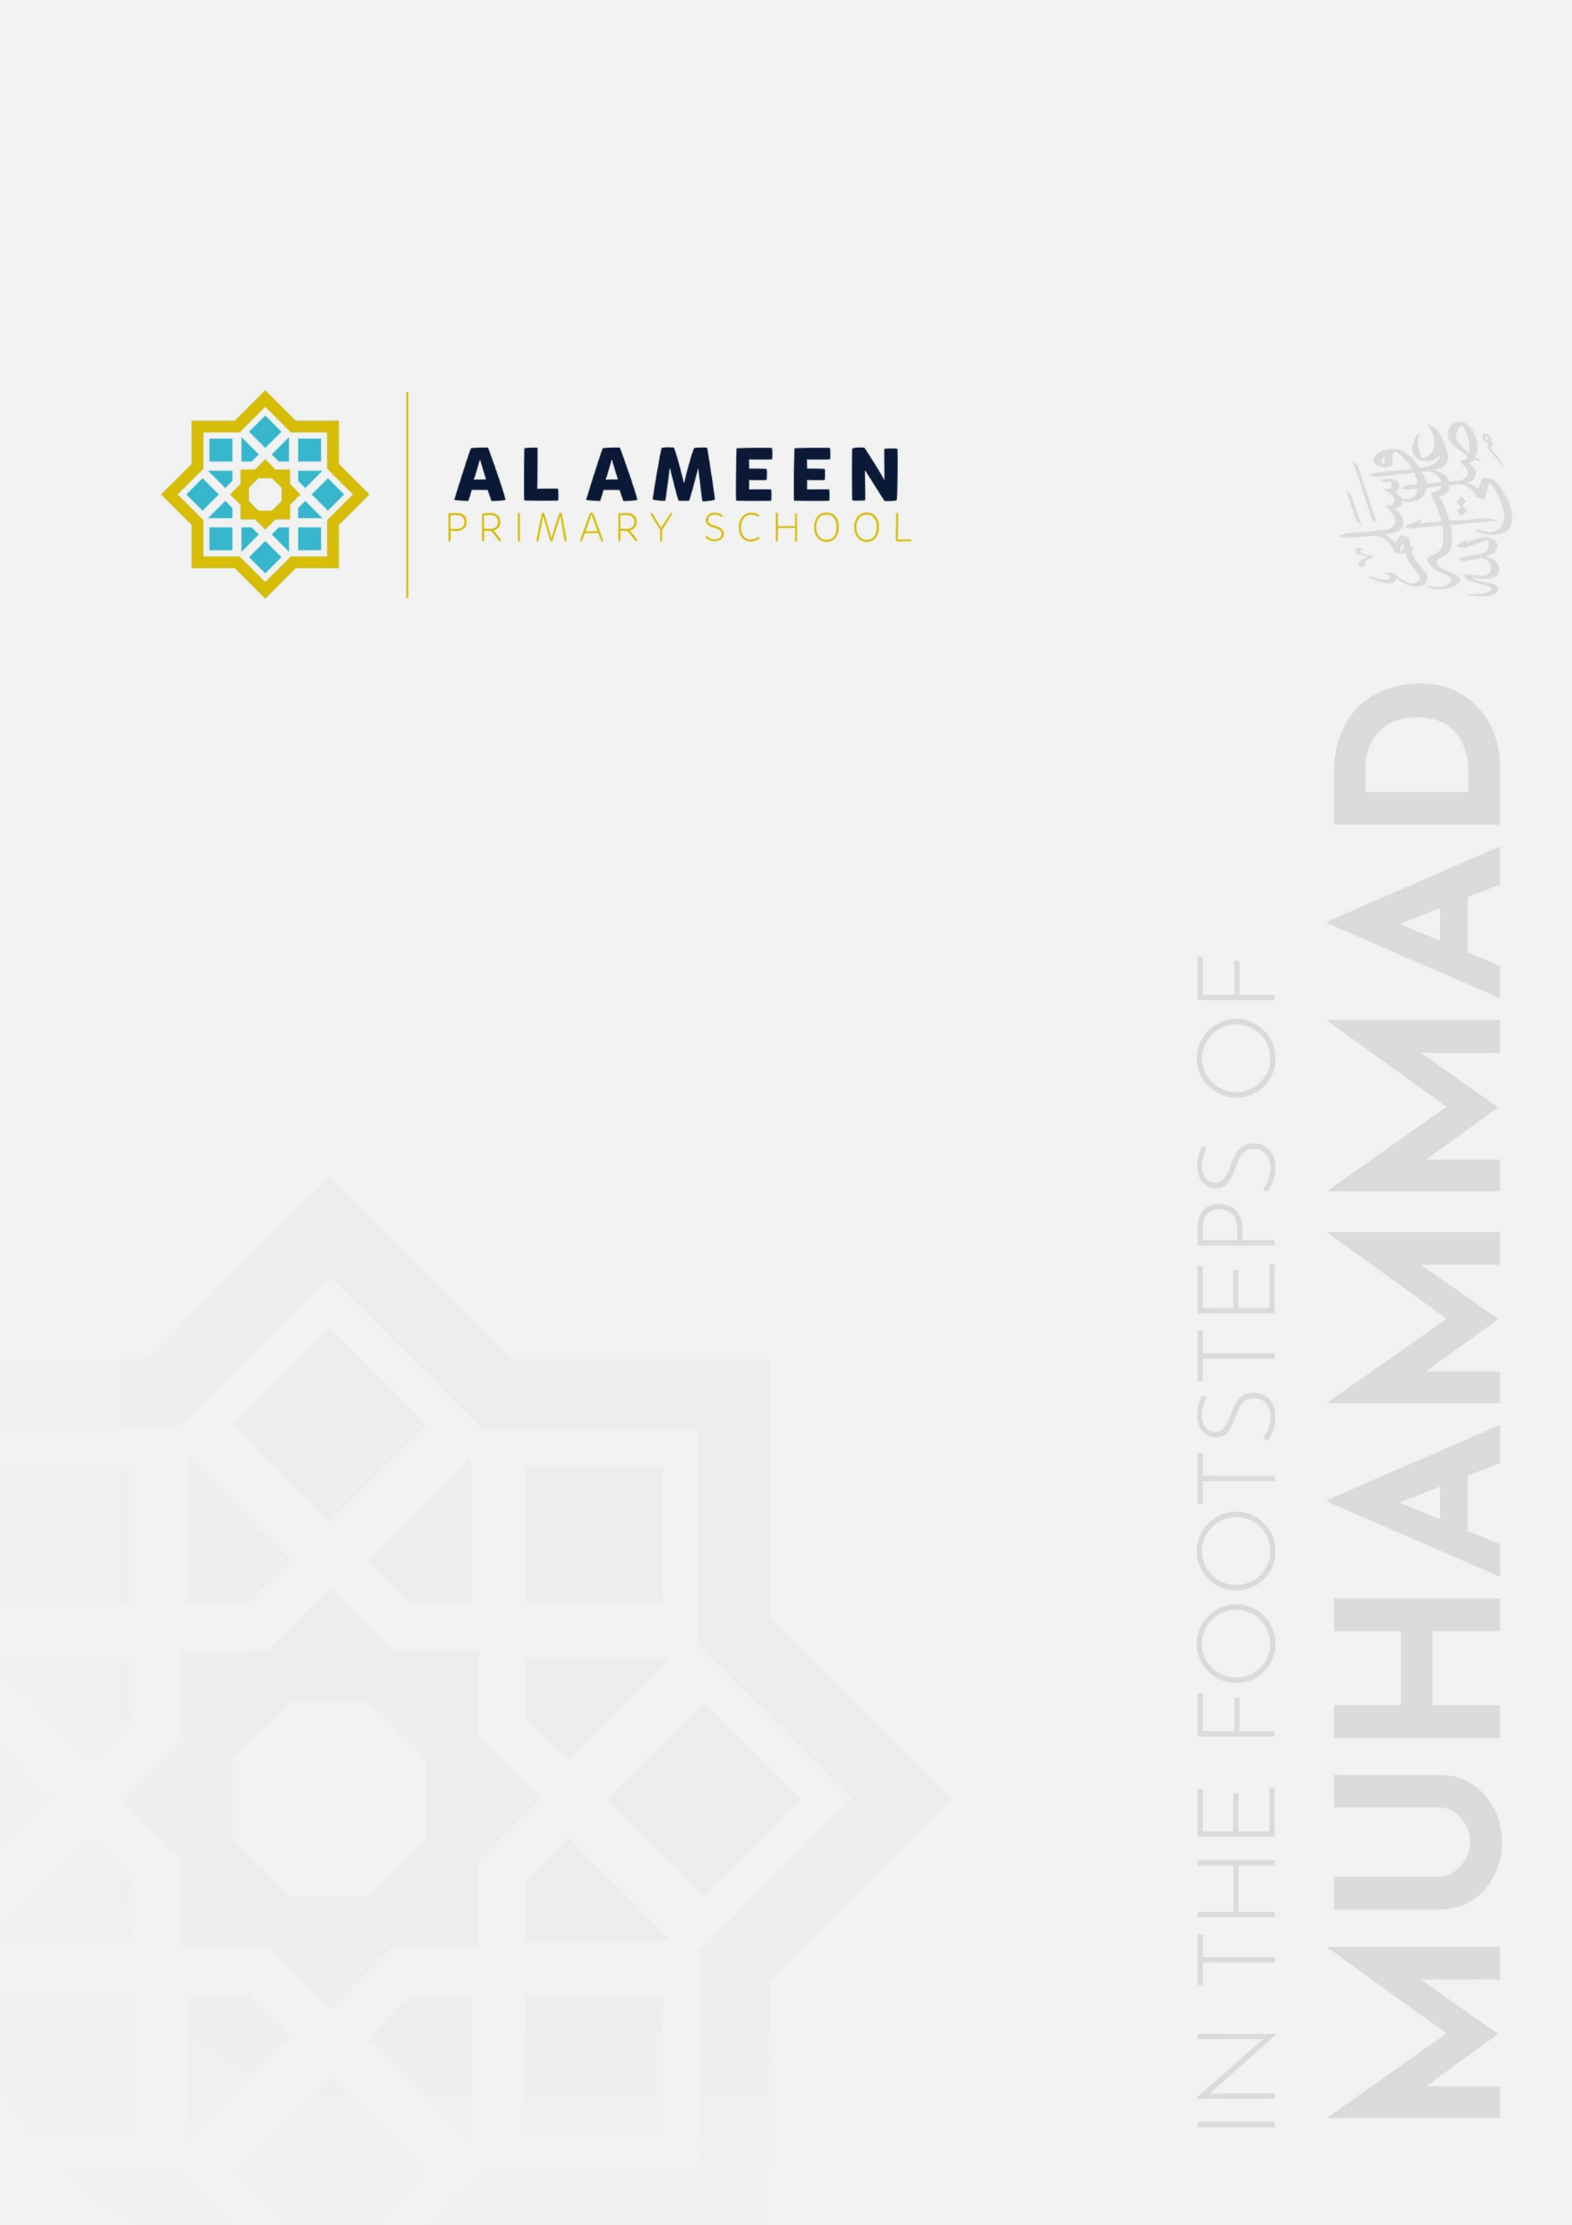

KEY PERSON
POLICY (EYFS)

Approved by: | Mohammed Rahman (Head Teacher)
Date effective from: | September 2026
Next review due by: | September 2027
Signed: | M A Rahman

In the name of Allah, The Beneficent, The Merciful
“We made you peoples and tribes so that you may know one another.” (Qur’an 49:13)
1. Statement of Intent
Al Ameen Primary School is committed to ensuring that every child in our Early Years Foundation Stage (EYFS) has a key person, so that their care is tailored to their individual needs and they, and their parents and/or carers, build a settled, trusting relationship with a named member of staff. Al Ameen Primary School's Early Years Foundation Stage (EYFS) provision welcomes children from the term after their third birthday. This policy forms part of the school's suite of EYFS policies, alongside the EYFS Policy, Safeguarding and Child Protection Policy, Allergy Safety Policy, Supporting Pupils with Medical Conditions Policy and First Aid Policy, and should be read alongside them.
2. Legal Framework
This policy is written with regard to:
• The Statutory Framework for the Early Years Foundation Stage (in force from 1 September 2026), paragraph 3.42, Key person.
• Paragraphs 3.34–3.36 on staff induction, training and supervision, and paragraphs 3.43–3.58 on staff:child ratios, which underpin how the key person system operates in practice.
3. Aims
• To ensure every child is assigned a named key person.
• To help every child feel safe, settled and valued, and to support their individual development.
• To build a genuine partnership between the key person and each child's parents and/or carers.
4. The Role of the Key Person
In line with paragraph 3.42 of the EYFS Statutory Framework, each child is assigned a key person, whose role is to:
• Help ensure that the child's care is tailored to meet their individual needs.
• Help the child become familiar with the setting.
• Offer the child a settled, secure relationship.
• Build a relationship with the child's parents and/or carers.
• Help families engage with more specialist support, where appropriate (for example, via the SENDCO, or external agencies).
5. Allocation of Key Persons
Every child is allocated a key person before, or on, their first day at Al Ameen. Key persons are matched to a small, consistent group of children, and are named to parents and/or carers at the child's induction and settling-in visits. Parents and/or carers are told how to contact their child's key person and are kept informed of any change.
6. Dual Key Persons (Part-Time Staff)
Where a child's key person works part-time, or where two key persons job-share a room, the school may allocate two named key persons who together provide continuous key-person cover across the child's attendance pattern, so that a key person who knows the child well is always present on the days they attend.
• Both key persons are introduced to the parent and/or carer at induction and are named to them as joint points of contact.
• The two key persons coordinate directly with each other, including a handover at the start and end of each working pattern change, so that observations, the child's learning journal, and any care or wellbeing information are shared and kept up to date between them.
• Parents and/or carers are told which key person is present on which days, and either key person can be contacted for day-to-day matters.
This dual key person arrangement is distinct from the “buddy” cover described in Section 7, which applies to planned or unplanned absence where a child otherwise has a single key person.
7. Continuity and Cover
Each key person (or, where a child has two key persons under Section 6, each of them) has a nominated “buddy” colleague within the EYFS team, who is familiar with the children in that key person's group and can step in during planned or unplanned absence, so that continuity of care is maintained. When a child moves between rooms or year groups (for example, from Foundation 1 to Foundation 2, or from EYFS into Year 1), a planned handover between the outgoing and incoming key person / class teacher takes place, sharing relevant information about the child's needs, interests and development.
8. The Key Person and Safeguarding
As the member of staff who knows a child best on a day-to-day basis, a key person is often well-placed to notice changes in a child's behaviour, presentation or wellbeing that may indicate a safeguarding concern. Any such concern is reported immediately to the Designated Safeguarding Lead (Mohammed Rahman) or a Deputy DSL (Nazia Sultana or Noreen Ghazala), in line with the Safeguarding and Child Protection Policy.
9. The Key Person and SEND
Where a child has, or may have, special educational needs and/or disabilities (SEND), the key person works closely with the SENDCO (Shefa Malik) to help identify needs early, contribute to individual support plans, and keep parents and/or carers informed and involved, in line with the SEND Policy.
10. Parent Partnership
The key person is the parent's and/or carer's main point of contact for day-to-day matters, and leads on settling-in visits, regular informal updates, parents' evenings, and the child's learning journal / observations. Parents and/or carers are encouraged to share information about their child's home life, routines and interests, so that the key person can plan care that reflects the whole child.
11. Staff Training and Support
Key persons receive induction training in this role and in child development, and are supported through regular supervision (EYFS Statutory Framework paragraphs 3.35–3.36), which provides an opportunity to discuss individual children's needs, wellbeing or safeguarding concerns, and to receive coaching and professional development.
12. Monitoring and Review
This policy is monitored by the Early Years Manager and reviewed annually, or sooner if there is a change to relevant legislation, statutory guidance, or the school's circumstances.

