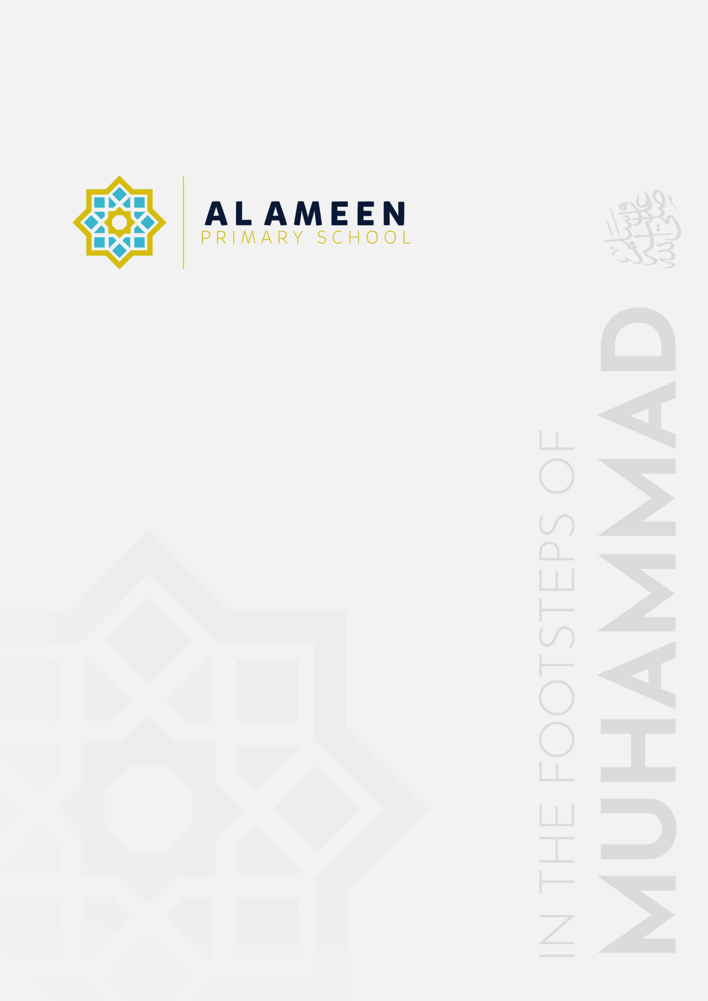

PRIMARY TEACHING AND
LEARNING POLICY

Approved by: | Mohammed Rahman (Head Teacher)
Date effective from: | September 2026
Next review due by: | September 2027
Signed: | M A Rahman

In the name of Allah, The Beneficent, The Merciful
“We made you peoples and tribes so that you may know one another.” (Qur’an 49:13)
1. Statement of Intent
Every child at Al Ameen Primary School has the right to the best possible education. The school aims to ensure that all pupils reach their full potential and gain the skills and knowledge necessary to lead successful lives, within a teaching and learning environment rooted in our Islamic ethos and preparing pupils for life in modern Britain.
This policy sets out the procedures and expectations that underpin high-quality teaching and learning throughout the school.
2. Legal Framework
This policy has due regard to all relevant legislation and guidance, including, but not limited to, the following:
• The Equality Act 2010.
• The DfE's ‘Special educational needs and disability code of practice: 0 to 25 years’ (January 2015).
• The Education (Independent School Standards) Regulations 2014, Schedule 1, Part 1, Standard 2 (quality of education) and the Independent School Standards guidance (DfE, April 2026).
• The ISI Inspection Framework (September 2026).
This policy operates in conjunction with the following school policies:
• SEND Policy.
• Assessment, Marking and Feedback Policy.
• Behaviour and Anti-Bullying Policy.
• Curriculum Policy.
3. Roles and Responsibilities
The Governing Body will be responsible for:
• Ensuring an effective approach to teaching and learning is implemented across the school.
• Ensuring high expectations are set for all pupils, regardless of their abilities or needs.
The Headteacher will be responsible for:
• Overseeing the school's approach to teaching and learning.
• Ensuring the needs of all pupils are met.
• Ensuring teachers are provided with support to deliver high-quality teaching.
• Promoting a culture of high-quality teaching across the school.
The SENDCO (Shefa Malik) will be responsible for:
• Ensuring pupils with SEND receive appropriate support within everyday teaching and learning, in line with the SEND Policy.
• Advising teachers on adapting planning and delivery to meet the needs of pupils on the Graduated Response, or with an Education, Health and Care (EHC) plan.
Teachers are responsible for:
• Monitoring and evaluating their teaching.
• Seeking opportunities to develop their teaching.
• Reviewing and evaluating their planning regularly.
• Setting appropriate and challenging targets for pupils based on ability.
• Collaborating with colleagues to moderate pupil achievement.
• Involving parents and other professionals in the monitoring process.
Support Teachers are responsible for:
• Working with class teachers during planning and preparation, to understand the needs of individual pupils.
• Supporting different focus groups at different times, including pupils with SEND, pupils with EAL, and academically more able pupils.
• Working on a one-to-one basis with a pupil where this is identified as needed.
4. Learning Environment
The school will create and maintain a learning environment that supports pupils to achieve their full potential. Teachers are responsible for ensuring their classrooms and other learning areas provide opportunities to maximise and enhance learning.
Teachers will ensure that learning spaces are used flexibly to facilitate different activities. Seating arrangements will be made in order to maximise pupils' learning experiences, and will be changed to suit different activities and to allow pupils to work independently and in groups.
Classroom displays will be changed on a termly basis and will be geared towards aiding learning, reflecting the school's Islamic ethos, and celebrating pupils' work, rather than providing distraction.
5. The Curriculum
As an independent school, Al Ameen is not required to follow the National Curriculum. The school has chosen to base the content of its curriculum broadly on National Curriculum programmes of study, as a matter of good practice, while shaping delivery around our Islamic ethos, in order to meet Independent School Standard 2(2)(a) (a curriculum which covers a broad range of subject disciplines) in full. Teachers will follow the relevant schemes of work outlined in the school's Curriculum Policy, which currently maps each subject as follows: Hamilton (English, Science), Power Maths (Mathematics), STEM (Computing), Twinkl (History, Geography, Art and Design, Physical Education), LCP and AMS (PSHE), Read Write Inc (Phonics), HeadStart (Guided Reading), and school-designed curricula (Islamic Studies, Arabic Language).
The school will ensure that the curriculum is broad and balanced. It will be carefully timetabled, and the content will be suitable for the age and ability of the pupils. The curriculum will be made accessible to all through differentiation and the provision of necessary resources. The school will also ensure that other aspects of learning, such as the development of social skills, self-esteem and Islamic character, form a significant part of pupils' education.
6. Planning and Preparation
Teachers will be expected to plan effectively and appropriately to ensure all pupils are given the opportunity to reach their full potential. Teachers will be provided with appropriate preparation, planning and assessment (PPA) time.
In line with expectations set across the whole school, lesson plans will:
• Be clearly linked to the curriculum.
• Be differentiated, to clearly show how pupils of all abilities are catered for.
• Have clearly identified learning objectives and success criteria, showing continuity from one lesson to the next.
• Highlight the strategies for learning designed to achieve the learning objectives.
• Clearly state the activities that will be undertaken.
• Explain how pupils will be grouped.
• Show how support teachers will be utilised to enhance learning.
• Contain a list of resources to be used during the lesson and how these resources will complement teaching.
• Highlight any opportunities for assessment and evaluation.
• Clearly state timings and structures of lessons.
Teachers will ensure their lessons are planned so they can be flexible, to ensure the needs of all pupils are met.
7. Lesson Delivery
Lessons will be balanced, in terms of teacher and pupil-led activities, and will cater for different learning styles. A range of lesson types will be used, including practical, visual, dramatic, investigative and group work.
Resources used to aid learning will be:
• Accessible to all pupils.
• Appropriate for the activities pupils undertake.
• The right quality for the task.
• Sufficient in range to allow pupils to make appropriate choices.
• Organised and regularly checked.
Support teachers will be actively involved in lessons to aid pupils' learning. They will be involved in prior planning and preparation, and will have a good knowledge of the needs of individual pupils. They will support different focus groups at different times (for example, pupils with SEND, pupils with EAL, and academically more able pupils). In some circumstances, support teachers will be deployed on a one-to-one basis with a pupil in need of additional help.
8. Supporting Pupils
High expectations will be set for all pupils, regardless of ability, circumstances or needs. The delivery and content of lessons will be sufficiently differentiated to ensure all pupils can access and achieve within the curriculum. Teachers will take account of all pupils' needs when developing their lessons.
Teachers will be aware of any pupils who may require specific support to access the curriculum, and will ensure this support is put in place. Where a pupil is not progressing as expected, they will be placed on the school's Graduated Response, with outcomes and support arrangements agreed with the pupil and their parents and reviewed regularly, in line with the SEND Policy.
The SENDCO (Shefa Malik) will ensure that pupils with SEND receive the appropriate support, in line with any EHC plans and the school's SEND Policy.
9. Marking and Assessment
Teachers will mark pupils' work and provide feedback in line with the school's Assessment, Marking and Feedback Policy.
Pupils will be assessed both formally and informally throughout the academic year, in line with the school's approach to assessment as outlined in the Assessment, Marking and Feedback Policy. Assessment outcomes will be used to inform teaching and learning strategies.
10. Working with Pupils and Parents
Pupils will be provided with opportunities to contribute to the teaching and learning strategies used in school. Teachers will ensure pupils fully understand their learning objectives and know what they need to do to meet these objectives.
The school will communicate with parents about their child's learning in a variety of ways, including the following:
• Parents' evenings.
• Letters home.
• Annual reports.
11. Behaviour and Attitude
All members of the school community will be responsible for developing a supportive learning culture. Staff will make sure that pupils understand that attitude to learning and behaviour are important aspects of maintaining a positive learning culture. The principles of the school's Behaviour and Anti-Bullying Policy will be implemented at all times.
Pupils will be encouraged to:
• Listen to each other.
• Adopt various roles in groups.
• Volunteer thoughts and opinions.
• Respect the thoughts, ideas and contributions of others.
• Give honest and positive feedback.
Teachers will recognise and reward achievements in various ways, including the following:
• Verbal praise during lessons.
• Commendation stickers.
• Calling the pupil's parents to praise the pupil.
• Sending a letter home praising the pupil.
• Inviting the pupil to see the Headteacher.
• Achievement assemblies.
• Credits towards the school's reward scheme.
Disruptive behaviour will be managed by teachers in line with the school's Behaviour and Anti-Bullying Policy.
To ensure that the quality of teaching is of the highest standard, all teachers will:
• Understand what excellent teaching is.
• Creatively plan and deliver lessons.
• Motivate pupils effectively.
• Enjoy and have a passion for teaching.
• Continue to learn and enhance their skills.
• Hold high expectations for all pupils.
• Understand how thinking and questioning develop learning.
• Be consummate professionals, embodying the school's Islamic ethos.
• Engage pupils of all abilities.
• Seek out and accept constructive feedback from peers, pupils and parents.
• Be given opportunities to lead.
• Involve parents and carers in their teaching.
• Understand and implement effective behaviour management strategies.
12. Monitoring and Reporting
This policy will be reviewed annually by the Headteacher and the Governing Body.

