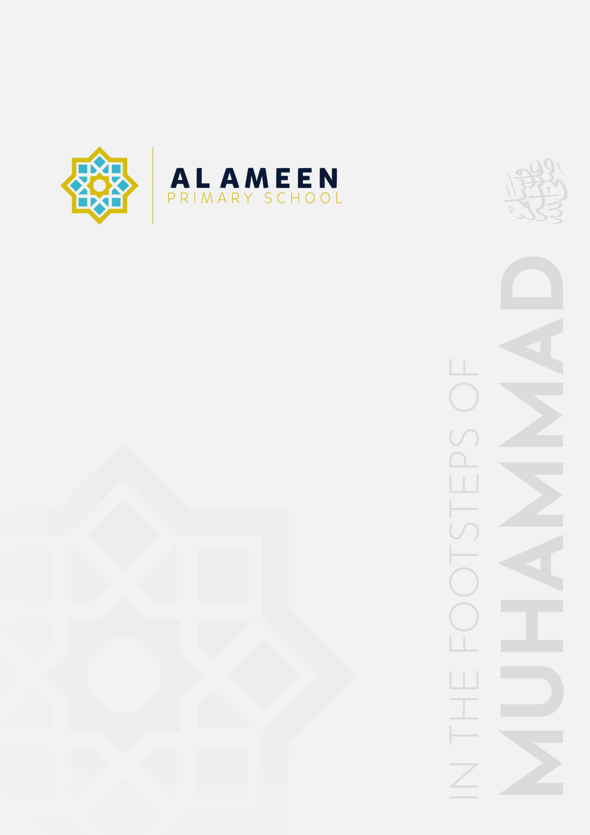

SAFER EATING AND
FOOD & DRINK POLICY (EYFS)

Approved by: | Mohammed Rahman (Head Teacher)
Date effective from: | September 2026
Next review due by: | September 2027
Signed: | M A Rahman

In the name of Allah, The Beneficent, The Merciful
“We made you peoples and tribes so that you may know one another.” (Qur’an 49:13)
1. Statement of Intent
Al Ameen Primary School is committed to promoting the good health of every child in our Early Years Foundation Stage (EYFS), including a healthy, balanced and nutritious diet, safe eating practices, and careful management of allergies, intolerances and special dietary requirements. Al Ameen Primary School's Early Years Foundation Stage (EYFS) provision welcomes children from the term after their third birthday. This policy forms part of the school's suite of EYFS policies, alongside the EYFS Policy, Safeguarding and Child Protection Policy, Allergy Safety Policy, Supporting Pupils with Medical Conditions Policy and First Aid Policy, and should be read alongside them.
2. Legal Framework
This policy is written with regard to:
• The Statutory Framework for the Early Years Foundation Stage (in force from 1 September 2026), Section 3 — Food and drink (paragraphs 3.59–3.73), including Safer eating (3.64), dietary information and allergies (3.65–3.66), weaning (3.67), choking prevention (3.68–3.71), food and drink facilities (3.72) and food poisoning notification (3.73).
• The Children and Families Act 2014, section 100, and the Children's Wellbeing and Schools Act 2026 (Benedict's Law) — see the school's Allergy Safety Policy and Supporting Pupils with Medical Conditions Policy.
• The Food Information (Amendment) (England) Regulations 2021 (“Natasha's Law”) and Food Standards Agency allergen guidance.
• The Early Years Foundation Stage nutrition guidance (non-statutory, referred to at paragraph 3.63).
3. Aims
• To provide healthy, balanced and nutritious food and drink for all children in our care.
• To keep children safe while eating and to reduce the risk of choking.
• To identify, record and manage every child's dietary requirements, allergies and intolerances before they are admitted to the setting, and to keep this information current.
• To ensure all staff understand their responsibilities around food safety, allergy awareness and safer eating.
4. Roles and Responsibilities
The Deputy Headteacher and Early Years Manager (Nazia Sultana) has overall responsibility for this policy in the EYFS setting. All staff working with EYFS children are responsible for following it. The school's Appointed Person for First Aid (Noreen Ghazala) supports staff with allergy and anaphylaxis training and coordinates allergy action plans alongside the SENDCO (Shefa Malik) where a child also has SEND.
5. Dietary Information and Allergies
Before a child is admitted to the EYFS setting, the school obtains information from parents and/or carers about any special dietary requirements, preferences, food allergies, intolerances and special health requirements the child has (para 3.65). This information is shared with all staff involved in preparing and handling food, and is recorded on the child's Individual Healthcare Plan (IHP) and the school's Allergy Register where relevant.
Where a child has a known allergy or intolerance, the school works with parents and/or carers and, where appropriate, health professionals, to develop and maintain an allergy action plan. All staff are made aware of the symptoms and treatment of allergies and anaphylaxis, and understand that children can develop allergies at any time. At each mealtime and snack time, a named member of staff is responsible for checking that the food and drink provided meets the requirements for every child present.
6. Safer Eating: Supervision
Whenever EYFS children are eating, a member of staff holding a valid, full-course paediatric first aid (PFA) certificate is present in the room (para 3.64). Children are always within sight and hearing of a member of staff while eating (para 3.70). Where possible, staff sit facing the children while they eat, so they can watch for signs of choking, prevent children sharing food, and notice any unexpected allergic reaction.
Babies and young children are seated safely in a highchair or an appropriately sized low chair while eating, in a designated eating space where distractions are minimised (para 3.69).
7. Preventing and Responding to Choking
Food is prepared in a way that reduces the risk of choking, following the Government's food safety guidance for early years providers (para 3.68) — for example, cutting grapes, cherry tomatoes and similar round foods lengthways, and avoiding whole nuts and other known choking hazards for young children. Staff are alert at all times to the fact that choking can be silent.
Where a child experiences a choking incident requiring intervention, the member of staff present will follow paediatric first aid procedure, and the incident will be recorded (where, how, and the action taken), with parents and/or carers informed the same day or as soon as reasonably practicable (para 3.71). Choking incident records are reviewed periodically by the Early Years Manager to identify any trends and to inform further risk reduction.
8. Weaning and Introducing Solid Foods
Al Ameen's EYFS provision admits children from the term after their third birthday, by which stage children have long since moved on to solid foods; the weaning-specific requirements at paragraph 3.67 do not typically apply to our cohort. Should the school ever admit a younger child (for example, a sibling in a holiday or wraparound provision), staff will have ongoing discussions with parents and/or carers about the foods and textures the child is used to, and will not make assumptions based on age, following NHS weaning guidance.
9. Food Safety, Hygiene and Facilities
The school maintains an area adequately equipped to provide healthy meals, snacks and drinks, with suitable facilities for hygienic food preparation (para 3.72). All staff involved in preparing or handling food receive food hygiene training. Fresh drinking water is always available and accessible to children (para 3.63).
10. Food Poisoning
In the event of suspected food poisoning affecting two or more children on the premises, the school will notify Ofsted (or the relevant Childcare on Domestic Premises register body) as soon as reasonably practicable and, in any event, within 14 days of the incident, in line with paragraph 3.73.
11. Menus and Nutrition
Meals, snacks and drinks provided by the school are healthy, balanced and nutritious, with regard to the EYFS nutrition guidance (para 3.63). Menus take account of religious and cultural dietary requirements (all food provided by the school is halal) as well as recorded allergies and intolerances.
12. Monitoring and Review
This policy is monitored by the Early Years Manager and reviewed annually, or sooner if there is a change to relevant legislation, statutory guidance, or the school's circumstances.

