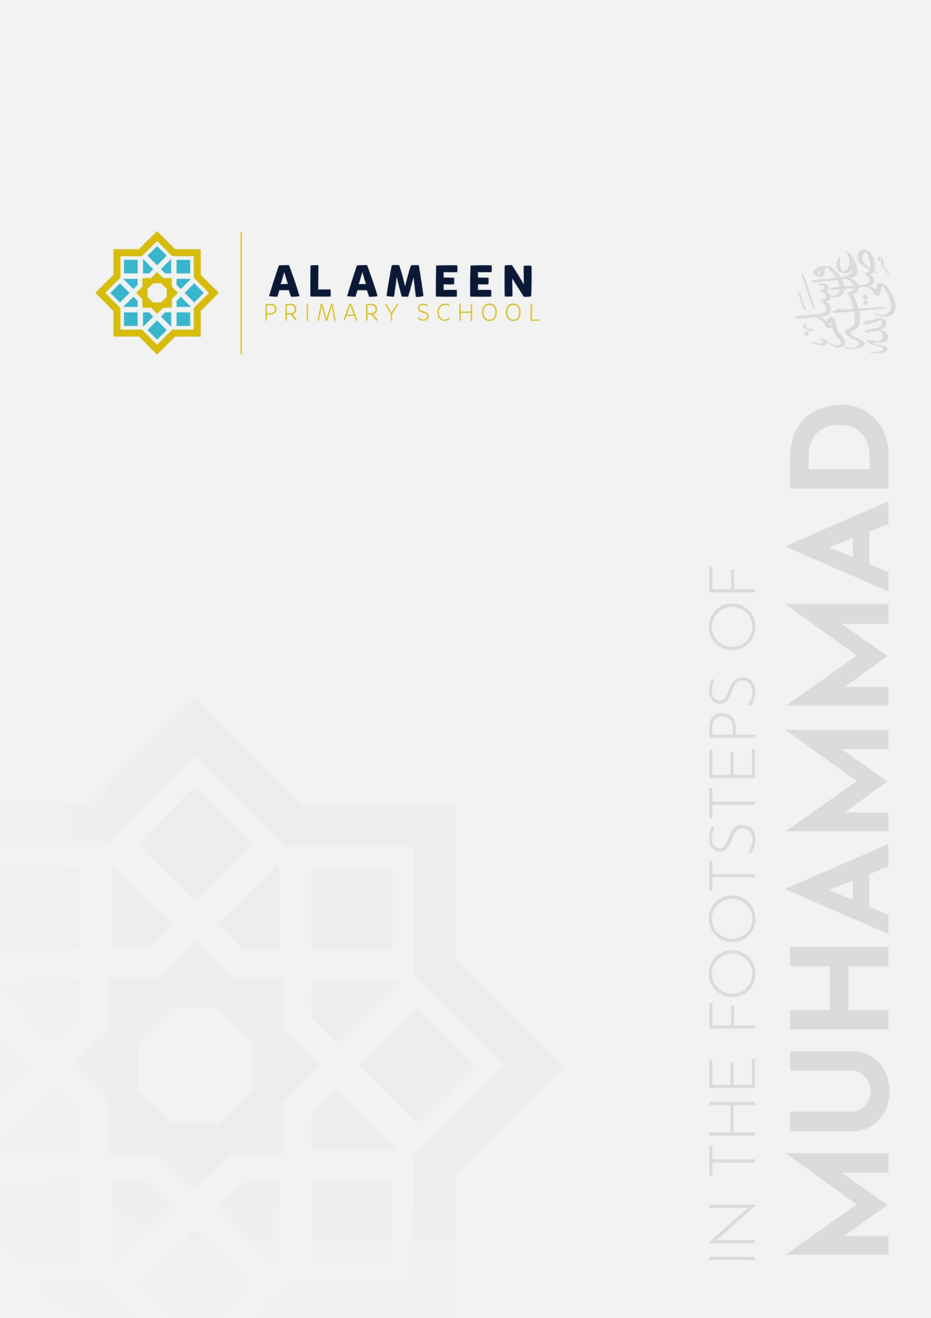

SLEEP AND REST
POLICY (EYFS)

Approved by: | Mohammed Rahman (Head Teacher)
Date effective from: | September 2026
Next review due by: | September 2027
Signed: | M A Rahman

In the name of Allah, The Beneficent, The Merciful
“We made you peoples and tribes so that you may know one another.” (Qur’an 49:13)
1. Statement of Intent
Al Ameen Primary School is committed to ensuring that every child in our Early Years Foundation Stage (EYFS) who sleeps or rests while in our care does so safely and comfortably, and that sleeping children are properly supervised at all times. Al Ameen Primary School's Early Years Foundation Stage (EYFS) provision welcomes children from the term after their third birthday. This policy forms part of the school's suite of EYFS policies, alongside the EYFS Policy, Safeguarding and Child Protection Policy, Allergy Safety Policy, Supporting Pupils with Medical Conditions Policy and First Aid Policy, and should be read alongside them.
2. Legal Framework
This policy is written with regard to:
• The Statutory Framework for the Early Years Foundation Stage (in force from 1 September 2026), paragraph 3.86, Sleeping arrangements, and paragraph 3.87, Baby room.
• NHS guidance on Sudden Infant Death Syndrome (SIDS).
• Safer sleep guidance from The Lullaby Trust.
3. Aims
• To reduce the risk of Sudden Infant Death Syndrome (SIDS) and other sleep-related harm.
• To ensure every sleeping or resting child is properly supervised.
• To provide a calm, comfortable rest and quiet-time routine for older EYFS children.
4. Applicability at Al Ameen
Al Ameen's EYFS provision admits children from the term after their third birthday. The great majority of our EYFS children are therefore not at the age where the cot-based safer sleep requirements below routinely apply, and their needs are met instead through the supervised rest and quiet-time arrangements at Section 7. However, this policy sets out the full statutory safer sleep requirements at Section 5, so that they are followed in full for any child under two who is ever in the school's care (for example, a younger sibling attending a holiday club or wraparound session), and so that all staff understand the underlying safer sleep principles that inform our general approach to supervised rest.
5. Safer Sleep Arrangements for Children Under Two
Babies and children must be placed down to sleep safely. For children under two years old, the following requirements apply in full (para 3.86):
• Children are placed down on their back, in their own separate sleep space, on a firm, flat surface such as a cot, bed, or mattress on the floor. Babies aged 12 months and under are only placed to sleep in a cot, carrycot, Moses basket or travel cot.
• Sleep spaces contain only a firm, flat, waterproof mattress and lightweight bedding, firmly tucked in around the child below their shoulders to prevent head covering; alternatively, a well-fitted baby sleep bag may be used, checking the manufacturer's recommendations first.
• Where blankets are used, the child is placed feet-to-foot at the bottom of the cot, with blankets tucked in.
• Cots do not contain extra items such as toys, pillows, extra blankets, bumpers, wedges or straps.
• Children are kept at a comfortable temperature; the recommended room temperature for babies is 16–20˚C.
• Children's heads are never covered.
• Babies under six months of age always have an adult with them in the same room for every sleep. All children are frequently checked while sleeping.
• Children are always within sight and hearing of staff when sleeping.
Staff follow NHS advice on Sudden Infant Death Syndrome (SIDS) and refer to further safer sleep guidance from The Lullaby Trust.
6. Baby Room
Where the school provides for children under two, a separate baby room is maintained, while ensuring children in the baby room have regular contact with older children and are moved into the older age group when appropriate (para 3.87). This does not currently apply to Al Ameen's provision but is retained here should the school's registration or intake ever change.
7. Rest and Quiet Time for Older EYFS Children
For our Foundation Stage children (age three and above), the school provides a supervised, calm rest or quiet-time period appropriate to each child's individual needs, rather than a formal sleep routine. Children who wish to rest are offered a comfortable, quiet space; those who do not need to sleep are offered a calm alternative activity (such as quiet reading or sensory play). Staff remain in the room throughout, and children resting or sleeping are always within sight and hearing of a member of staff.
8. Recording and Communication with Parents
Where a child sleeps while in our care, staff record the time the child fell asleep, checks carried out, and the time they woke, and share this with parents and/or carers at collection. Any parental preference or medical need relating to sleep or rest is recorded on the child's individual records and followed.
9. Staff Training
All staff working in the EYFS setting are made aware of this policy and of safer sleep practice as part of induction and the school's ongoing safeguarding and welfare training.
10. Monitoring and Review
This policy is monitored by the Early Years Manager and reviewed annually, or sooner if there is a change to relevant legislation, statutory guidance, or the school's circumstances.

